G7 has 'no time to lose' to cut rare earths dependency, Germany minister says
By Reuters
May 18, 20265:28 PM GMT+1Updated 5 hours ago
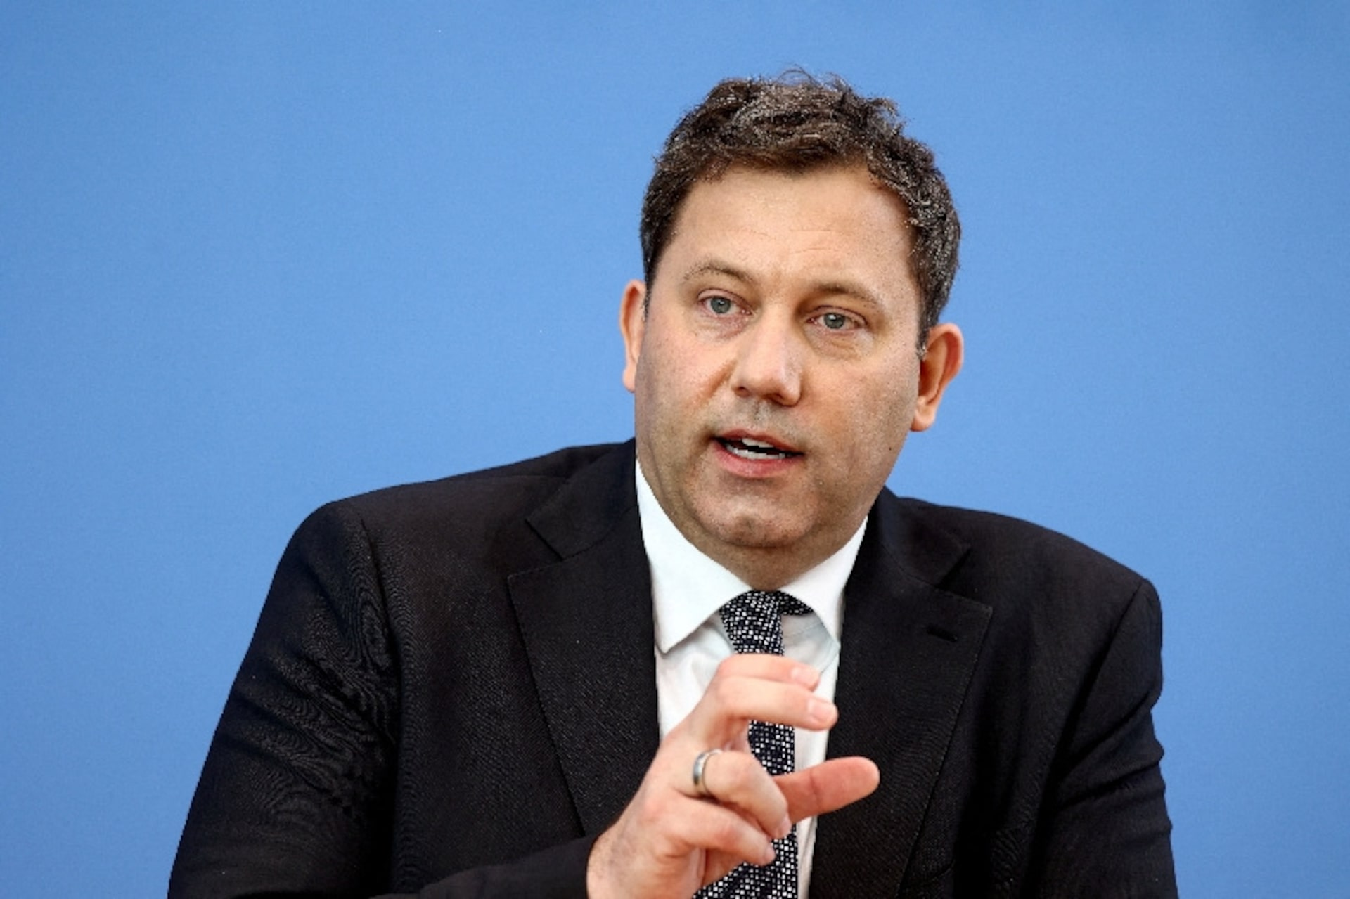
German Finance Minister Lars Klingbeil holds a press conference on the government's 2027 budget guidelines and the 2028–2030 financial plans, in Berlin, Germany, April 29, 2026. REUTERS/Liesa Johannssen/File Photo Purchase Licensing Rights, opens new tab
PARIS, May 18 (Reuters) - G7 countries have options ‌to reduce their dependency on rare earths, but have no time to lose, German finance minister Lars Klingbeil said during a summit in Paris on Monday.
G7 governments are trying to ​coordinate efforts to reduce their reliance for critical minerals and rare earths ​on China, which dominates supply chains vital for technologies such ⁠as electric vehicles, renewable energy and defence systems.
The Reuters Iran Briefing newsletter keeps you informed with the latest developments and analysis of the Iran war. Sign up here.
Advertisement · Scroll to continue

"We should not fall into a ​tone of complaint ... Instead, we have to work on our strength," Klingbeil told ​reporters.
Klinbeil, who is also Germany's vice chancellor, said he met French President Emmanuel Macron for a one-hour private meeting in which they discussed how to strengthen Europe's sovereignty.
"We agree that ​the Franco-German axis is important to move Europe forward, especially in these ​times," he said, adding that projects would need to be brought forward before the next ‌election.
Ministers ⁠from six leading European economies including Germany and France vowed to be the drivers of progress in the region in January as they tackled how to advance projects stalled by the EU's complex decision-making process.
Advertisement · Scroll to continue

Klingbeil said G7 countries must improve ​procurement and look at ​where rare earths ⁠production can be expanded. He also proposed recycling quotas, setting targets or requirements to recover and reuse a minimum ​share of critical raw materials.
"So the proposals are all on ​the table ⁠and we have no time to lose," Klingbeil said, adding that the Iran war has exposed G7 countries' dependency on fossil fuels, just as the war in ⁠Ukraine ​exposed Germany's dependency on Russian gas.
"We have to ​be very careful here not to run into the next dependency, one which, to be honest, we ​are already in."

